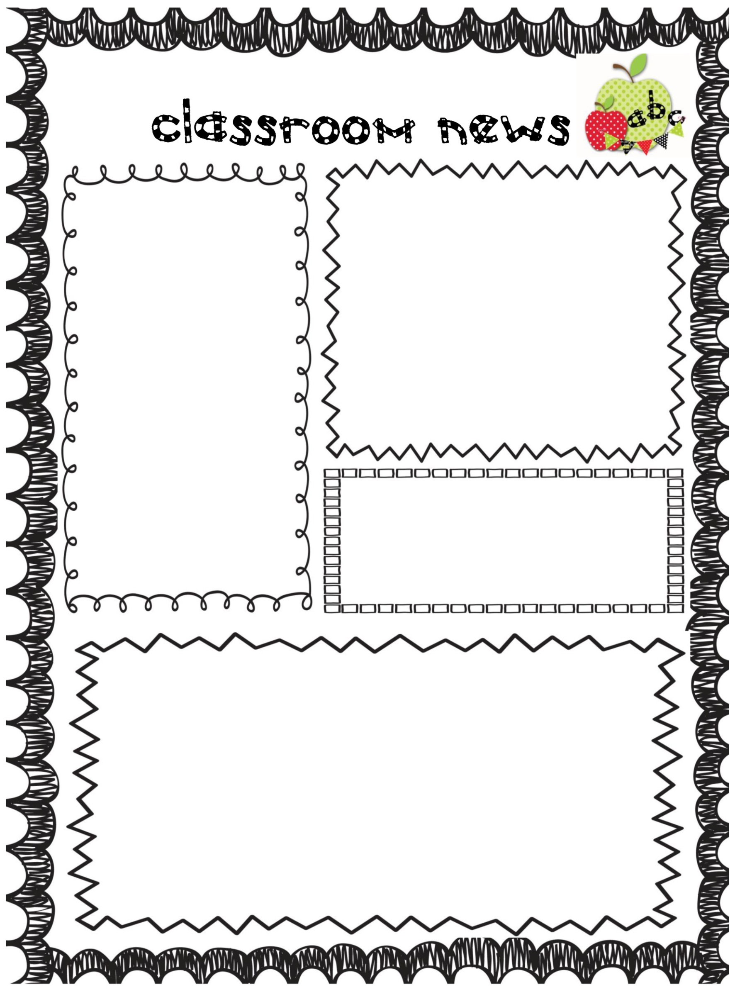S

**Learning Centers**

We have a few openings to teach. If you would like to sign up please go to our classroom website under the calendar tab. If you need materials or lesson suggestions, I am very willing to assist you in any way. Leave a message on the sign-up sheets and I will respond or email me.

**This month’s benchmark goal is knowing all the letters and their sounds.**

**Homework**

Spelling words will be given out this week to all students. Please refer to your child’s list to practice. Your child will be practicing their spelling words during their independent reading time as well. Each student’s specific list will be place on Scoot Pad so that they can practice there as well.

**Up Coming Events**

**Friday, December 9th** we will be having holiday learning centers in our classroom. **Wednesday, December 21st** is the annual sing around—more information about this event will follow. **Thursday, December 22nd** is spirit day, our classroom Holiday party, and a short day. There will be no school **Friday 23rd – Monday, January 2nd** due to the Holiday Break.